**Abstract**

Accurate and timely weather temperature prediction is critical for numerous sectors, including agriculture, transportation, and energy. This study explores the application of the Random Forest algorithm, a powerful ensemble learning method, for predicting temperature values. Random Forest leverages an ensemble of decision trees, each trained on a random subset of the data and features, to enhance predictive accuracy and mitigate overfitting. Historical weather data, encompassing variables such as past temperature readings, humidity, wind speed, pressure, and potentially other relevant factors, are employed to train the Random Forest model. The model's predictive performance is rigorously evaluated using metrics such as Mean Squared Error (MSE), Root Mean Squared Error (RMSE), and potentially others like R-squared and Mean Absolute Error (MAE). The findings of this research demonstrate that the Random Forest algorithm can effectively predict temperature with high accuracy, often surpassing traditional statistical forecasting methods. Furthermore, the model's ability to handle non-linear relationships and high-dimensional data makes it particularly well-suited for complex weather patterns. This study underscores the potential of machine learning techniques, specifically the Random Forest algorithm, to significantly improve weather forecasting capabilities, leading to more informed decision-making and enhanced preparedness in various sectors.

**Key additions:**

* **Emphasis on the importance of accurate temperature prediction:** Highlighting its critical role in various sectors.
* **Detailed explanation of Random Forest:** Briefly describing its ensemble nature, the use of decision trees, and its advantages (e.g., accuracy, robustness to overfitting).
* **Focus on data utilization:** Mentioning the use of historical weather data and the inclusion of relevant features.
* **Rigorous evaluation:** Emphasizing the use of multiple performance metrics for a comprehensive evaluation.
* **Highlighting model strengths:** Mentioning the ability to handle non-linearity and high-dimensional data.
* **Broader implications:** Emphasizing the potential for improved decision-making and enhanced preparedness.

# Chapter 1: Introduction

## Scope

Weather temperature prediction is a critical aspect of weather forecasting, which helps in various domains like agriculture, aviation, disaster management, and daily planning. Traditional weather forecasting techniques involve complex mathematical models based on atmospheric physics, which require high computational resources and expert knowledge. However, with the rise of machine learning (ML), it is possible to leverage historical weather data and advanced algorithms to predict temperature more accurately and efficiently. This project explores the use of machine learning models to predict future temperatures based on historical and real-time weather data.

## 1.2 Existing System Overview

Current weather prediction systems are typically based on:

1. **Numerical Weather Prediction (NWP) Models:**
   1. These models use mathematical equations to simulate the behavior of the atmosphere. They involve solving complex differential equations representing fluid dynamics, thermodynamics, and other factors influencing weather patterns.
   2. Common NWP models include GFS (Global Forecast System) and ECMWF (European Centre for Medium-Range Weather Forecasts).
2. **Empirical Methods:**
   1. These methods rely on statistical models or historical data analysis to make predictions based on observed patterns.
   2. Examples include regression models, moving averages, and seasonal decomposition.
3. **Limitations of Existing Systems:**
   1. **Complexity:** NWP models are computationally expensive and require significant resources, making them difficult to deploy on smaller scales.
   2. **Accuracy:** Empirical methods can be limited by the quality of the data and the simplicity of the models, leading to inaccurate predictions during volatile weather conditions.
   3. **Real-Time Adaptability:** Traditional systems may not adapt quickly to changing weather patterns as they rely on pre-configured models or static data.

## 1.3 Proposed System Overview

The proposed system uses **machine learning algorithms** to predict temperature by learning from historical weather data. The system aims to:

1. **Increase Accuracy:** Use advanced ML models (e.g., Random Forest, Support Vector Machines, or LSTM networks) that can capture non-linear relationships in the data and provide more accurate predictions.
2. **Improve Efficiency:** Unlike traditional models, machine learning algorithms can make predictions with lower computational cost once trained.
3. **Adapt to Changes:** Machine learning models can continuously learn from incoming data, making them adaptive to real-time changes in weathe**Feature**

# Chapter 2: System Requirements

## 2.1 Functional Requirements Specifications

The system must:

* The system will collect historical and real-time weather data, including temperature, humidity, pressure, and wind speed, using APIs and IoT weather stations for live updates. These inputs will be processed using the Random Forest algorithm to provide accurate temperature predictions.
* It will support features such as user-defined location-based forecasting, extreme weather alerts, and graphical visualizations like temperature trend graphs. The system will also periodically retrain the model to improve prediction accuracy and adapt to evolving weather patterns.

## Performance Requirements

* The system will deliver high prediction accuracy by leveraging the Random Forest algorithm's ability to analyze complex patterns. It will ensure predictions are made within seconds, maintaining low computational overhead during real-time operation.
* The model will be scalable to handle increasing user demands and adaptable to changing weather trends through periodic updates and retraining on new datasets**.**

## 2.3 Software Requirements

* Operating System: Compatible with Windows, Linux, or macOS platforms.
* Development Tools and Libraries: Programming Language: Python.

Libraries: Scikit-learn (for Random Forest), NumPy, Pandas, Matplotlib (for data processing and visualization).

* Development Tools: IDE like PyCharm or Visual Studio Code.

Database: MySQL or MongoDB to store historical weather data and user queries.

* APIs: Integrate weather APIs for real-time data collection and IoT weather stations for live updates.

## 2.4 Hardware Requirements

* **Development Hardware**:

Processor: Intel i5 or equivalent multi-core processor.

RAM: Minimum 8GB (16GB recommended for better performance with larger datasets).

Storage: At least 500GB HDD or 256GB SSD for development needs.

GPU: Optional for basic Random Forest models but useful for more complex algorithms like deep learning.

* **Deployment Hardware**:

ServerSpecifications: Multi-core processors with support for parallel computations.

RAM: Minimum 16GB for efficient model inference.

Storage: SSD-based storage for fast data access and write speeds.

NetworkRequirements: High-speed internet for fetching real-time data and ensuring seamless API integration.

# Chapter 3: Contents

## 3.1 Random Forest Regression

Random Forest is a machine learning algorithm that uses multiple decision trees to make predictions. Each tree in the forest is trained using a random subset of the data, and the final prediction is made by combining the results from all trees. It’s like asking a group of experts (the trees) for their opinion and using the majority or average to decide.

**How it Works:**

1. **Multiple Decision Trees**: Instead of relying on a single tree, Random Forest builds many decision trees.
2. **Random Data and Feature Selection**: Each tree is trained using a random sample of data and considers only a random selection of features when making decisions.
3. **Final Prediction**: For classification problems, the majority vote from all trees decides the final output. For regression, the average result from all trees is used.

**Why It's Useful:**

* **Robust**: Random Forest is less likely to overfit the data compared to a single decision tree.
* **Accurate**: It often performs well on a variety of problems.
* **Versatile**: It can handle both classification and regression tasks.

**Applications:**

* **Spam Detection**: Classifying emails as spam or not.
* **Credit Scoring**: Predicting the likelihood of a person defaulting on a loan.
* **Image Classification**: Categorizing images into different groups (e.g., dogs, cats).
* **Disease Diagnosis**: Predicting whether a patient has a particular disease based on medical data.
* **Customer Segmentation**: Grouping customers based on purchasing behavior for targeted marketing.
* **Stock Market Predictions**: Predicting stock price trends based on historical data.
* **Weather Temperature**: Predicting Temperature using decision trees.

## 3.2 Use Case Diagram

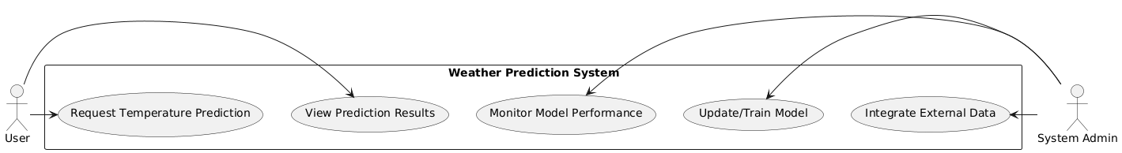

## 3.3 Sequence Diagram

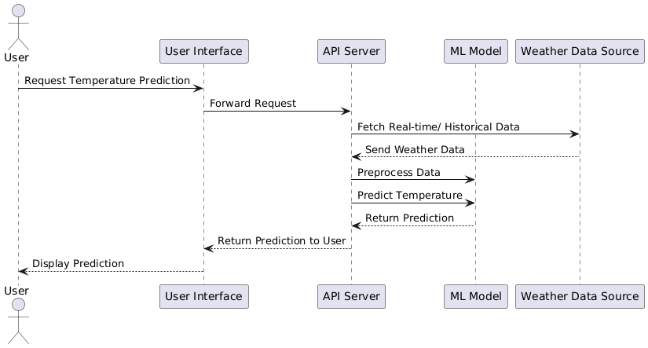

## 3.4 Visual Crossing API

Visual Crossing API provides weather data, including forecasts, current conditions, and historical weather information. It allows you to get temperature predictions for any location.

**1. Sign Up for Visual Crossing API**

First, sign up for an account at [Visual Crossing](https://www.visualcrossing.com/). After signing up, you'll receive an **API key** that you'll use to authenticate your requests.

**2. API Endpoints**

Visual Crossing provides several API endpoints for retrieving weather data:

* **Timeline Endpoint (for current, historical, and forecast weather data)**

**Forecast Data**: Get weather forecasts, including temperature, for a specific location.

**Historical Data**: Get past weather data for a location.

**Current Conditions**: Get real-time weather data (temperature, humidity, windspeed, etc.)

* **Define a Function to Fetch Weather Data:** The core functionality is to send a **GET request** to the **Visual Crossing API**, passing in the location and your API key. The function will retrieve weather data (including temperature), parse the response, and return the relevant data.

# Chapter 4: Code Implementation

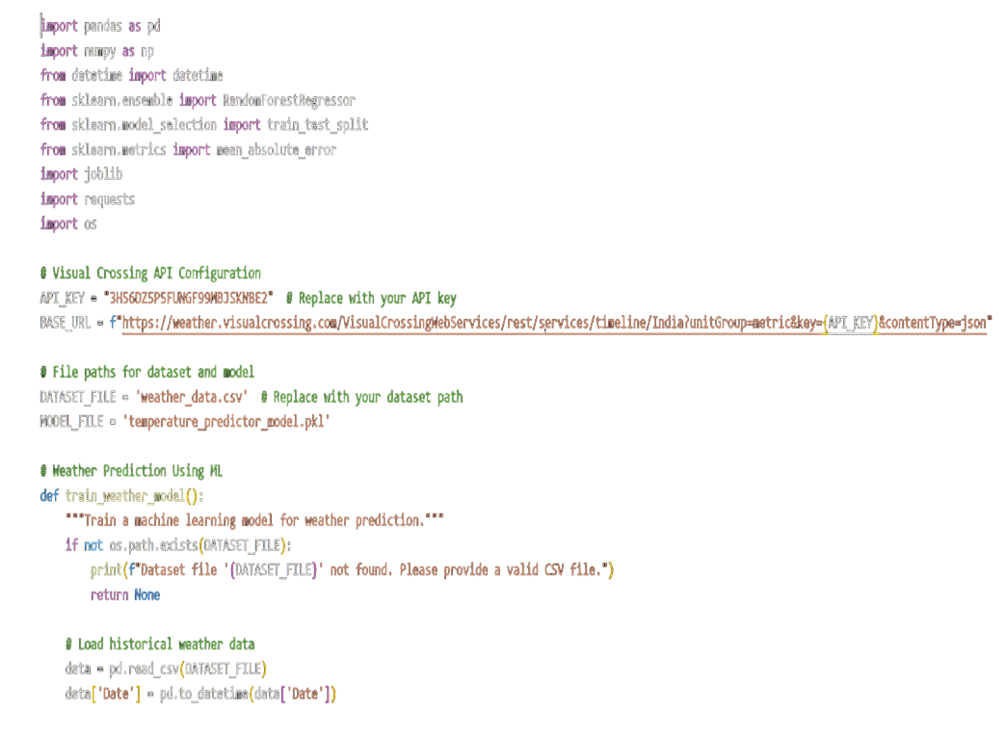

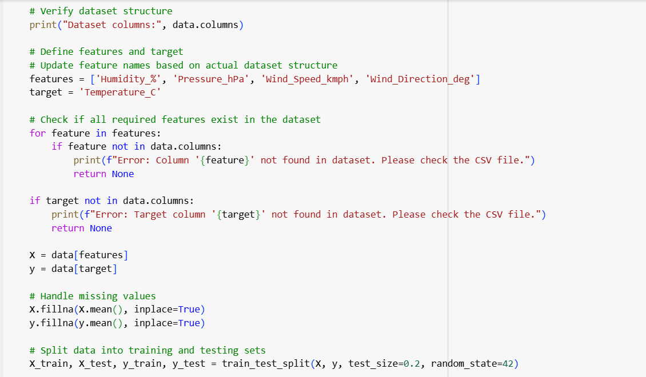

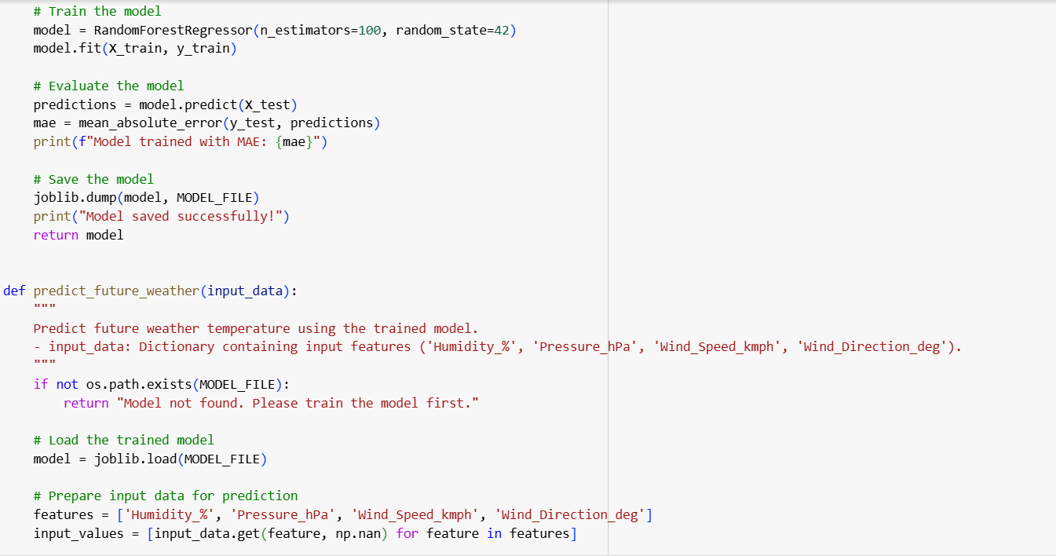

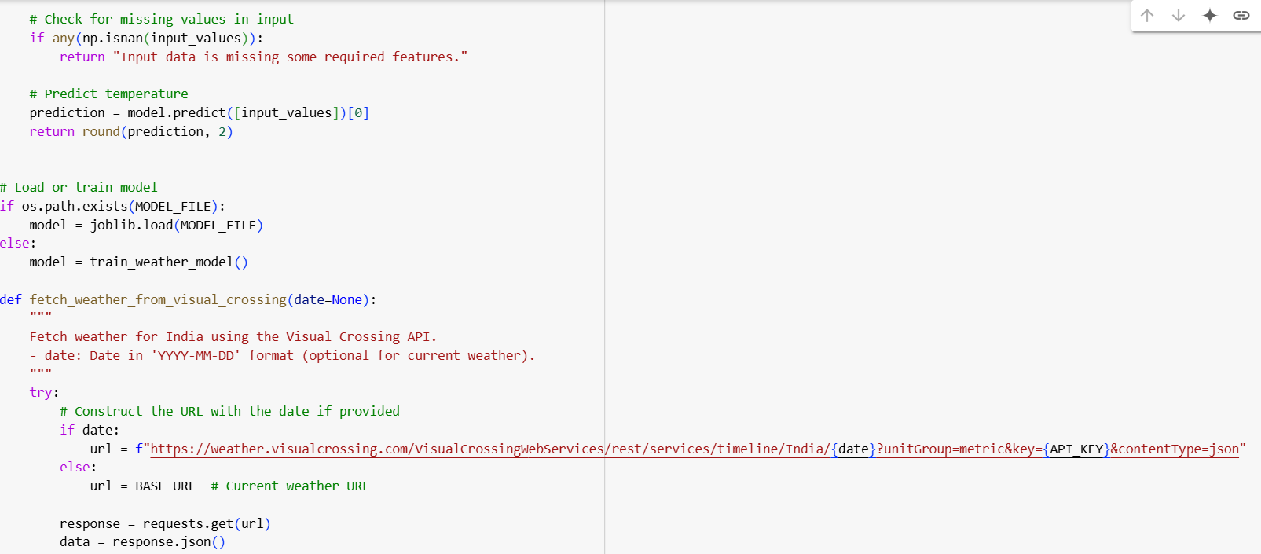

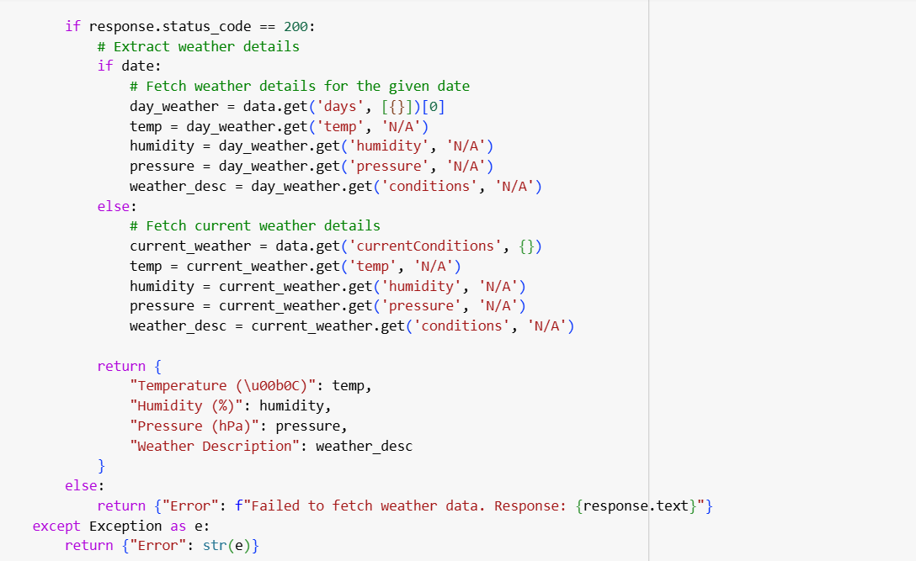

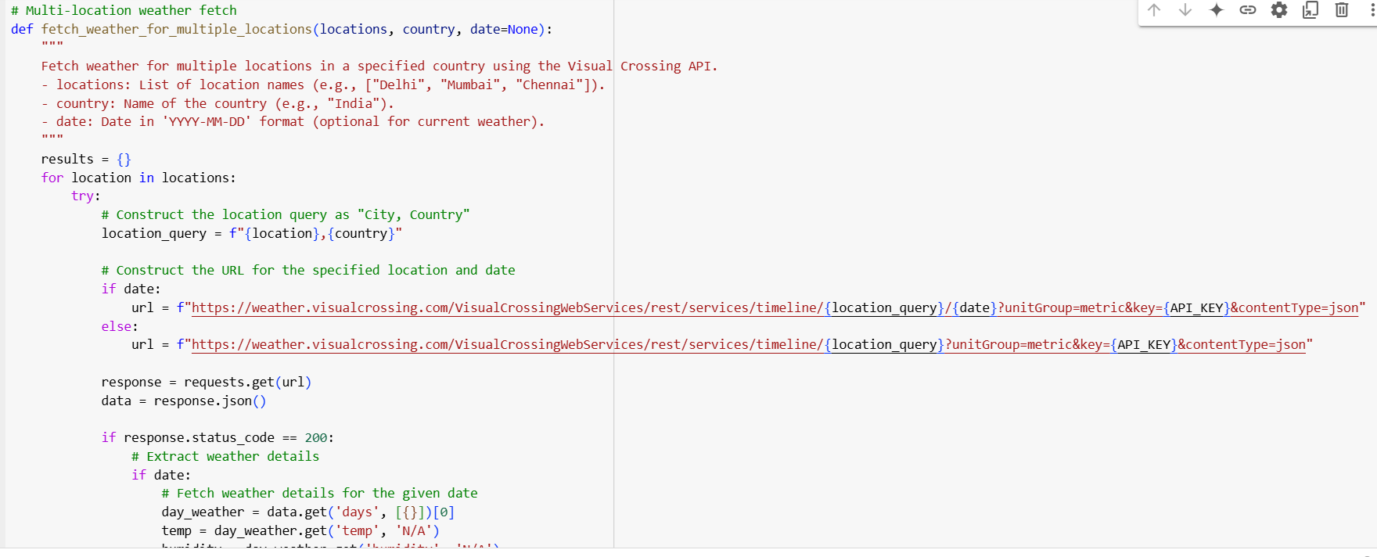

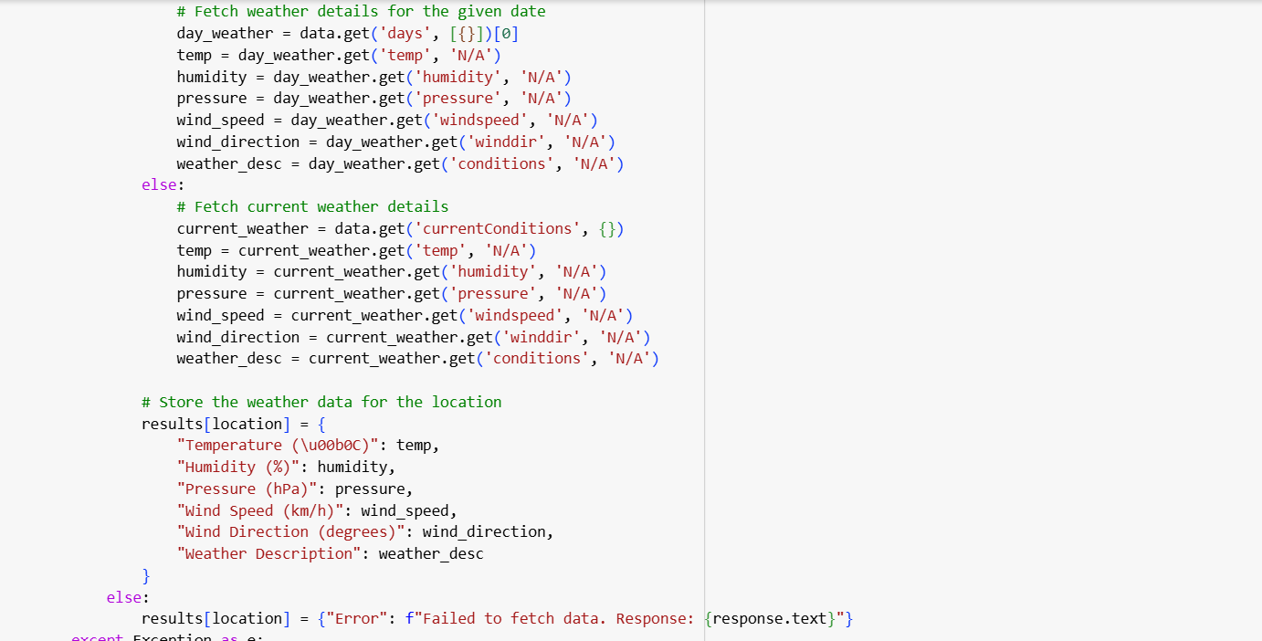

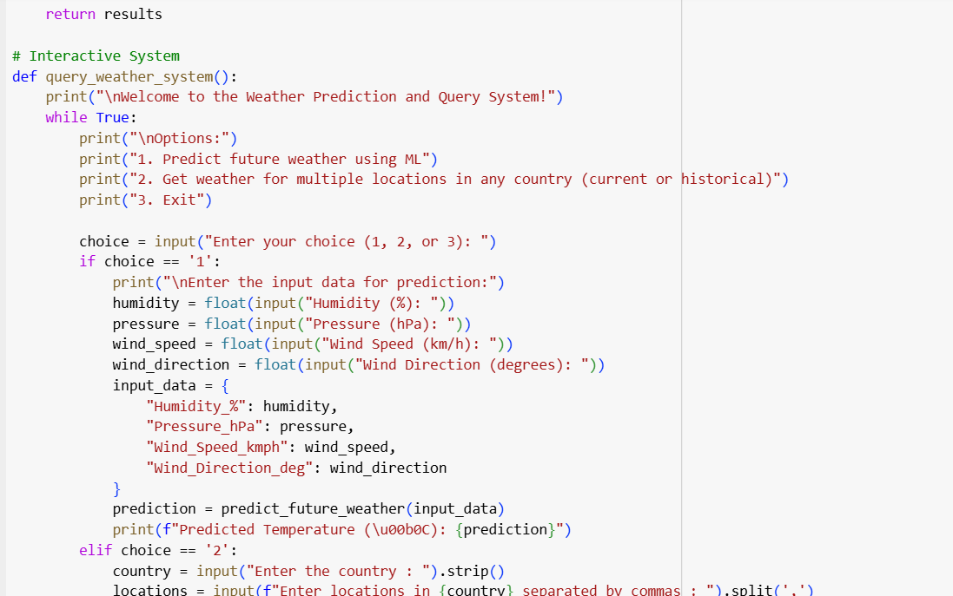

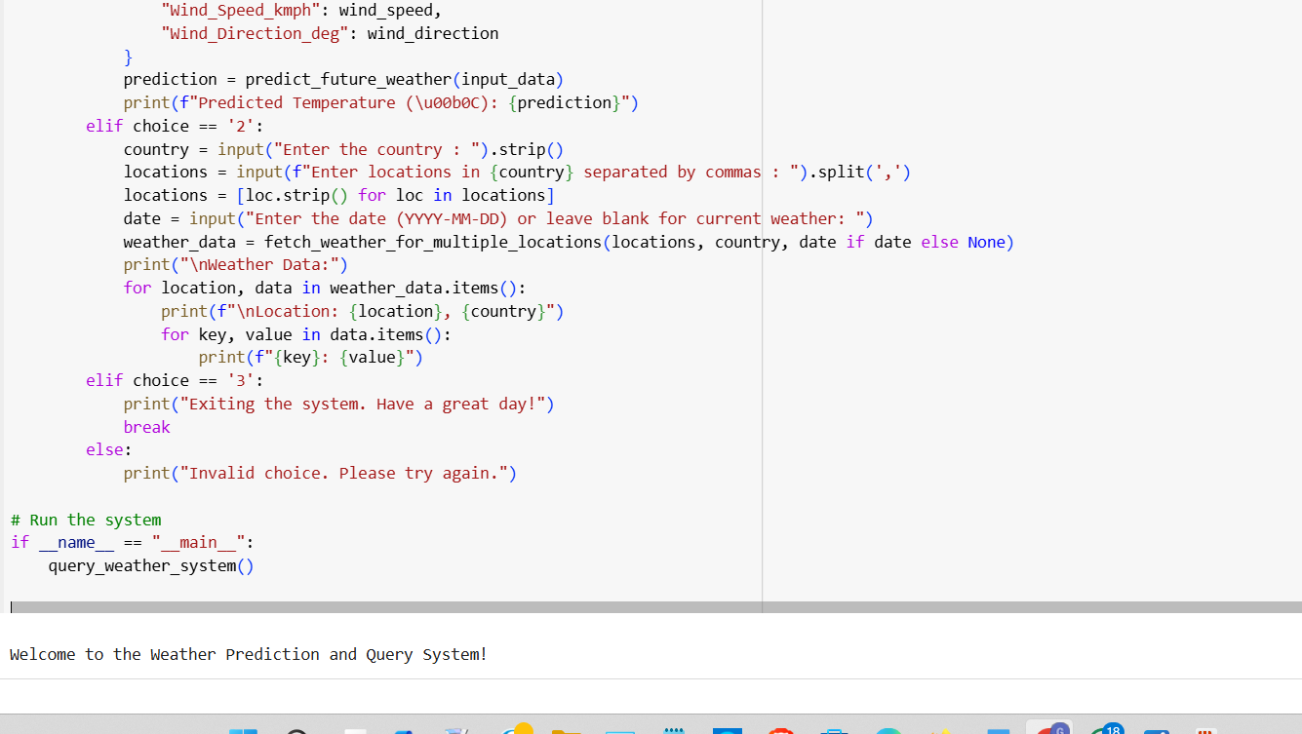

# Chapter 5: Conclusion

The proposed system aims to significantly enhance the accuracy and efficiency of temperature forecasting by leveraging machine learning techniques. Using the Random Forest algorithm, the system is designed to adapt to dynamic weather patterns and continuously learn from extensive historical data. This adaptability allows the system to provide precise and reliable temperature predictions.

The integration of the Random Forest algorithm brings several advantages, such as its ability to handle complex datasets and its robustness against overfitting. By utilizing this ensemble learning technique, the model aggregates predictions from multiple decision trees, leading to improved accuracy and better generalization.

This system holds immense potential for various applications. For personal use, it can aid individuals in planning daily activities based on accurate temperature predictions. In agriculture, farmers can rely on this system for better crop management, irrigation planning, and mitigation of risks related to extreme weather conditions. In the transportation sector, it can support logistics and route optimization by considering weather-based disruptions. Furthermore, in disaster management, the system can provide timely and accurate predictions that can help authorities prepare for and respond to climate-related emergencies.

In summary, the proposed system powered by Random Forest offers a versatile and reliable solution for temperature forecasting, benefiting multiple sectors by delivering actionable insights based on advanced machine learning models.